Business Modeling

Discipline Document

INF-F Analysis and Software Design

**Project:**

**Date:**

**Owner:** *<responsible subgroup>*

**Version:**

**Document History**

**Revision History**

|  |  |  |
| --- | --- | --- |
| **Version** | **Revision date** | **Summary of changes** |
| 0.1 | 20-02-2014 | Business Process Diagram added in Chapter 3.2 |
| 0.2 | 12-03-2014 | Update Business Modeling discipline |
| 0.3 | 12-03-2014 | Adding business rules |

**Distribution**

This document is intended for:

|  |  |  |  |
| --- | --- | --- | --- |
| **Name** | **Function** | **Date of issue** | **Version** |
|  |  |  |  |
|  |  |  |  |
|  |  |  |  |
|  |  |  |  |
|  |  |  |  |
|  |  |  |  |
|  |  |  |  |

**Table of Contents**

**1.** **Introduction**

**2.** **Business Use Case Diagram**

**3.** **Chosen Business Process**

**3.1.** **Business Use Case Specification**

**3.2.** **Business Process Diagram**

**3.3.** **Business Activity Diagram**

**4.** **Business Rules**

# Introduction

# Business Use Case Diagram

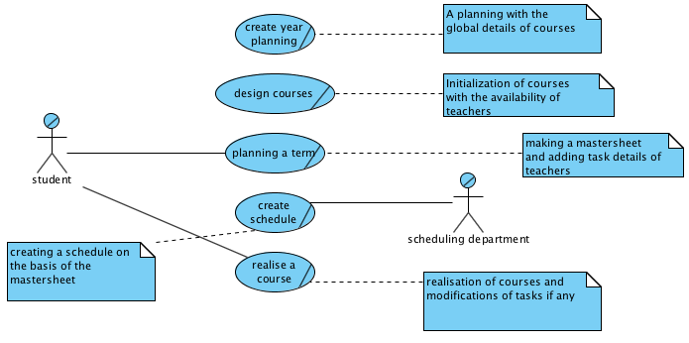

# Chosen Business Process

## Business Use Case Specification

|  |  |
| --- | --- |
| *Business use case:* | Planning a term |
| *Business actor:* | Team manager |
| *Business worker(s):* | Scheduling department |
| *80% scenario* | **Precondition:**  Use case course planning has successfully produced course parameters.  **Scenario:**  The team manager has a consultation with the teachers about specific teacher details which shall be used in the mastersheet. Then, the team manager imports the course parameters, number of enrolled students and specific information of the year into the mastersheet. The team manager assigns teachers to tasks and shows the PTO of the teacher for confirmation. The team manager can change possible task details after the revision of the PTO by the teacher. Team manager sends the mastersheet to the scheduling department.    **Postcondition:**  Scheduling department has received the detailed mastersheet. |
| *20% scenario* | **Precondition:**  Use case course planning has successfully produced course parameters.  **Scenario:**  The team manager imports the parameters into the mastersheet. The team manager assigns teachers to tasks in the mastersheet. The workload, given in the mastersheet is incorrect.  **Postcondition:**  The mastersheet has incorrect workload values. The course manager has to reassign the task workload values in the course parameter. |

## Business Process Diagram

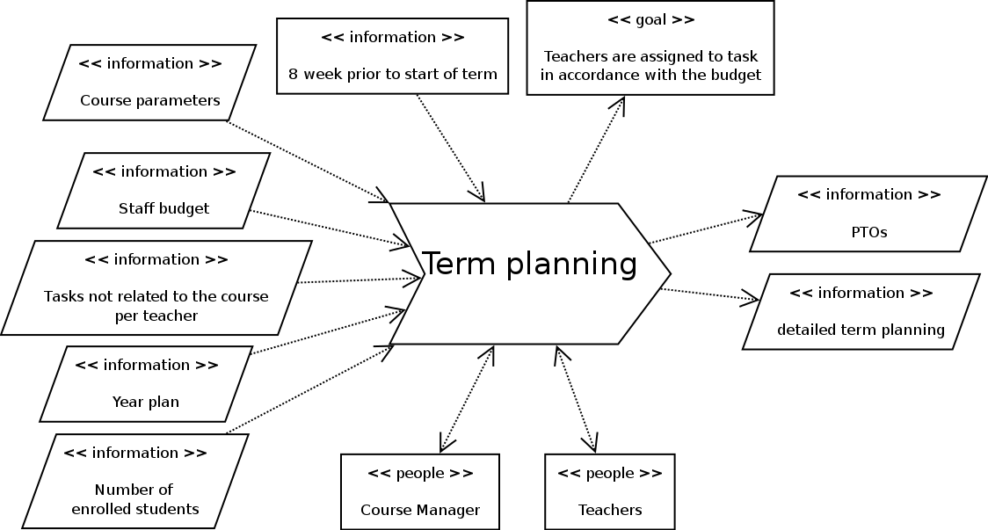

## Business Activity Diagram

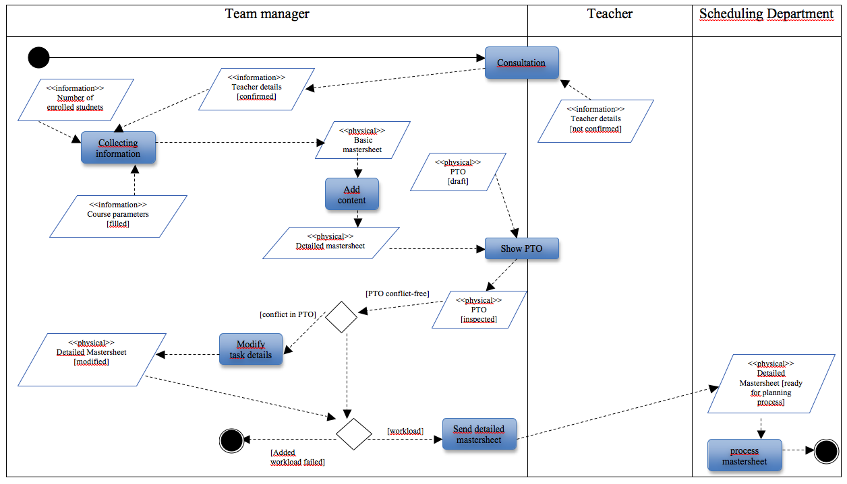

# Business Rules

|  |  |  |  |
| --- | --- | --- | --- |
| **B1** | Fulltime teachers can give lessons during the day and in the evening. | Team manager | CASE |
| **B2** | Teachers specific to part-time students can only teach in the evening. | Team manager | CASE |
| **B3** | In a PTO teacher tasks are inventorised for 10 weeks. | Team manager | CASE |
| **B4** | Assignment of annual tasks to teachers happens in May / June. | Team manager | CASE |
| **B5** | Every teacher gets assigned tasks according to their working hours. | Team manager | CASE |
| **B6** | Budget in hours for the main phase is 15 * 0.6 * number of enrolled students. | Course manager | CASE |
| **B7** | An activity is carried out by one or more teachers. | Scheduling department | CASE |
| **B8** | An activity cannot be divided into sub-activities, due to a limitation of the Iris program. | Scheduling department | CASE |
| **B9** | An activity can be linked to a type of classroom, but this is not a necessity. | Scheduling department | CASE |
| **B10** | An activity must be bound to 1 or more groups of students. | Scheduling department | CASE |
| **B11** | A group should not be smaller than two students. Groups larger than 8 are not allowed. | Scheduling department | CASE |
| **B18** | A group of students follow a specific course during a specific period in time. | Scheduling department | CASE |
| **B12** | A teacher can not be scheduled for an activity on a day or an hour (hours) that the teacher indicated in their scheduling preferences as non-available unless teacher says otherwise. | Scheduling department | CASE |
| **B13** | Team managers should make schedule preferences known before the scheduling process begins. | Scheduling department | CASE |
| **B15** | A request for a change in the schedule is a request by the course manager to change one or more scheduled activities in the (draft) schedule. | Scheduling department | CASE |
| **B16** | Every room has a specific room type. | Scheduling department | CASE |
| **B17** | A room type describes the most important properties of a specific room. | Scheduling department | CASE |